The first information about the village of Tarchomin comes from the 13th century. It was a noble village inhabited by the Jastrzębiec family.
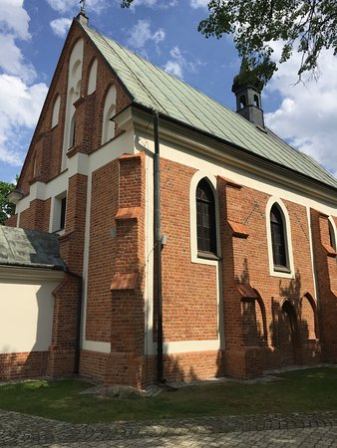
In the 19th century, Olędrzy - Mennonite colonists settled in the area of ​​Tarchomin. Their presence is evidenced by the ruins of the cemetery at Mehoffera Street in Tarchomin, next to the present cemetery.
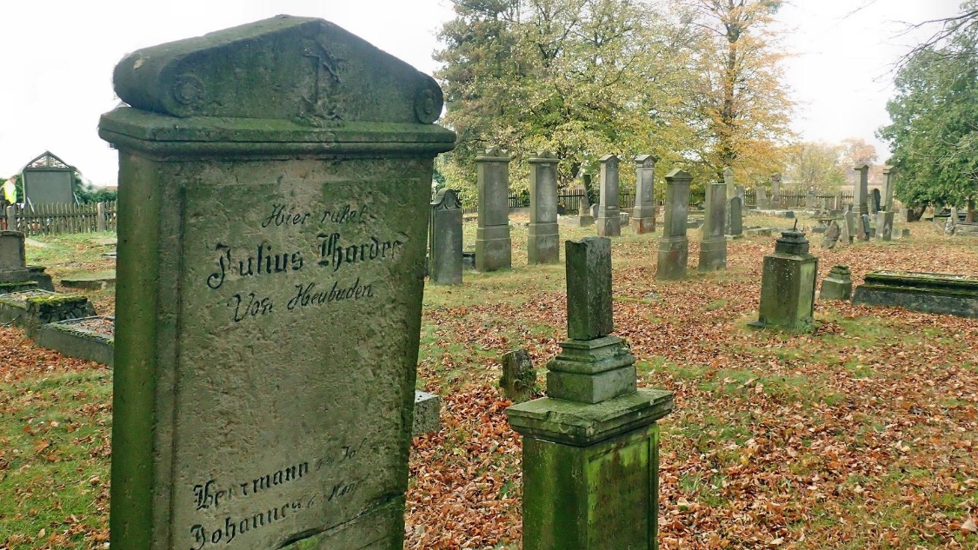
In 1823, a vinegar factory was established in Tarchomin, which after 1860 became a significant producer of artificial fertilizers, and in later years it produced drugs and cosmetics under the name of Przemysłowo-Handlowe Zakłady Chemiczne Ludwik Spiess i Syn. Its traditions since.
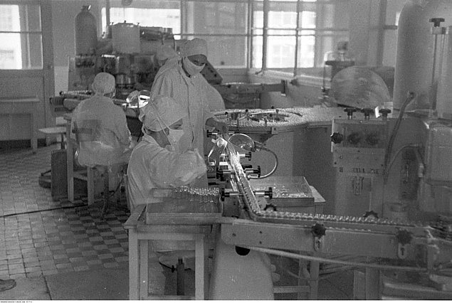
In the second half of the 19th century, there was a manor house and several farms in the Tarchomin area. In the interwar period, the village of Tarchomin was part of the Jabłonna commune.
During the German occupation, there was a labor camp for the Jewish population in Tarchomin (in Piekiełek), liquidated in November 1942.
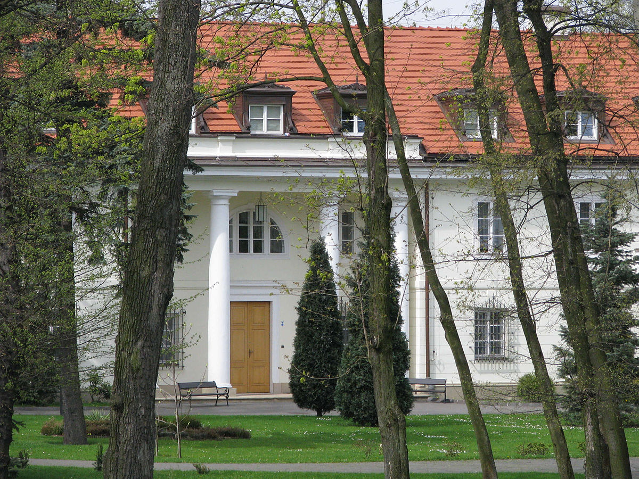

The area of ​​Tarchomin was incorporated into Warsaw in 1951.
In the 20th century, the building of the Białołęka District Office was built.
The area of ​​Tarchomin was incorporated into Warsaw in 1951.
In the 20th century, the building of the Białołęka District Office was built.
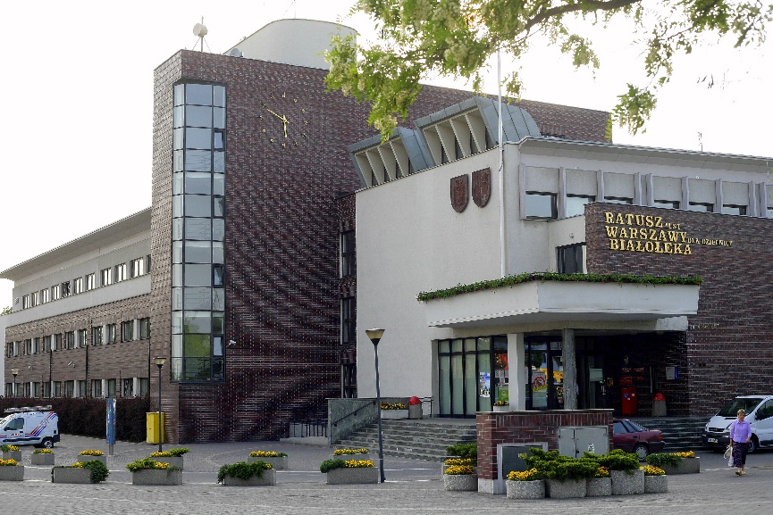
The Maria Skłodowska-Curie bridge, opened on March 24, 2012, facilitated communication with the left-bank part of the city.
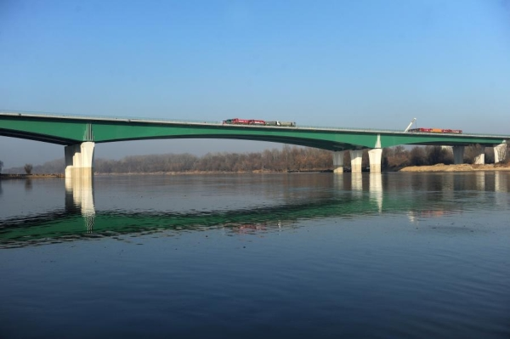

In September 2017, the Galeria Północna shopping mall was opened at the intersection of Światowida and Trakt Nadwiślańskiego Streets.
